**Modernizing IT Infrastructure with Google Cloud.**

**Course Introduction.**

Hello, and welcome to the Value of Infrastructure and Application Modernization with Google Cloud.

I'm Saman Javan, lead course developer and certified facilitator here at Google Cloud.

Consumer expectations over the last 20 years have radically changed.

Customers now expect connected digital experiences in real time.

Many businesses, especially large traditional enterprises, built their IT infrastructure on premises.

Legacy systems and applications make up the organization's IT backbone.

At the same time, these legacy systems and applications struggle to achieve the scale and speed needed to meet modern customer expectations.

Business leaders and IT decision makers constantly have to choose between maintenance of legacy systems, and investing in innovative new products and services.

In this course, I'll explore the challenges of an outdated IT infrastructure, and then describe how businesses can modernize that infrastructure using cloud technology.

In Module One, I'll introduce infrastructure modernization as the core topic, In particular, I'll examine compute options available in the cloud and the benefits of each.

I'll also present a few Google cloud solutions and highlight customers who have successfully used them.

In Module Two, I'll focus on application modernization.

Applications are not new in the cloud.

But cloud technology enables businesses to develop, deploy, and update applications with speed, security and agility built it.

I'll also cover App Engine, a Google Cloud solution that lets application developers build scalable web and mobile applications on a fully managed serverless platform.

In the third module, I'll present application programming interfaces, or APIs, and explain how they unlock value from legacy systems, enable businesses to create new value, and monetize new services.

I'll also cover Apigee, a Google Cloud Platform for developing and managing APIs.

I'll then close the course summarizing the key points and offer additional resources for you to continue your learning.

And remember, you don't need to be an IT specialist to create new business value or to develop innovative services.

By understanding how infrastructure, applications, and APIs work together, you can initiate conversations about new projects and be more knowledgeable about strategic planning for digital transformation.

We'll test your knowledge throughout the course with graded assessments, which you'll need to pass to receive credit.

Let's jump in.

**Introduction.**

Hello, and welcome to the first module: Modernizing IT Infrastructure with Google Cloud.

New businesses born in the cloud are challenging old business models.

Scale is no longer a competitive advantage; it's the norm.

Many organizations are very aware of this threat coming from digital disruption.

What organizations want to know is how to best respond to this threat.

How can they survive and thrive in this new cloud era?

Central to an organization's ability to thrive in the new era is the way in which they structure and use their IT resources.

This could mean moving away from investing resources to run and maintain existing IT infrastructure to focusing more on creating new higher value products and services.

With Cloud, organizations can develop and build new applications to drive better engagement with customers and employees faster, securely, and at scale.

And ultimately, leveraging cloud technology to truly transform a business requires new collaborative models, changing culture and processes, and enabling team productivity and innovation.

Enterprises are also seeing significant financial benefits from adopting Cloud as their approach to IT moves from buying fixed capacity to paying only for what they use, changing the economics of technology investment.

For many businesses, infrastructure modernization is the foundation for digital transformation.

And with that, here's what I'll cover in this module.

I'll begin by explaining what it means to modernize an IT infrastructure and why it matters.

Then the different compute options available.

Next, I'll cover private, hybrid, and multi-cloud architectures and what we mean by each of them.

I'll briefly go over Google Cloud's global infrastructure, and close with Google Cloud compute solutions for setting up or modernizing the IT infrastructure.

Remember, even if you're not in an IT or technical role, understanding this foundation will help you identify how you can support or drive your organization's cloud adoption goals.

So let's get started.

**Infrastructure Modernization.**

For most organizations, owning and operating infrastructure does not differentiate their business.

In fact, it's often a burden. (*carga*)

It limits an organization staff in several ways.

For example, they have to undertake laborious tasks related to infrastructure procurement, provisioning and maintenance. They are using legacy systems that are old, don't add value to the business other than keeping the lights on, and don't support business change. They cannot scale with any ease because they're locked into what they have on premises and forced to pay to over provision for peak usage.

One option for reducing this burden is to outsource the company's IT infrastructure as much as possible, and migrate to the cloud. But before we talk about migrating to the cloud, let's go back to a time before the cloud.

I'll demonstrate how technology has impacted company business models over the years and use a simplified IT backbone to talk through the various changes.

First, let's look at employees, the technology users. These people use or create applications on laptops or computers. And as part of their day to day work, they're storing data or files and connected to each other over the internet. As a company grows, and there's a need for more computers with more processing power, a company might have a data center with servers. Organizations might own their servers, data centers, cooling systems, the physical security features in place and the real estate to house all of that infrastructure. On top of this, they have to pay for maintenance and ongoing security costs.

Think of this as similar to owning a house.

You're responsible for all of the infrastructure, the bricks and mortar, the fence around your garden, the locks on your door and all of the ongoing costs such as your utilities as well. The first step in moving away from what we call an on premises infrastructure is colocation. Here, a business sets up a large data center, then other organizations rent part of that data center. This means organizations no longer have to pay for the cost associated with hosting the infrastructure, but they still need to pay to maintain it. It's like owning an apartment in a serviced apartment complex or a house in a gated community. You've paid for some infrastructure, the apartment or the house, and you're still responsible for maintenance-- for example, if your heater breaks down-- but some things like the perimeter security are outsourced. With both on premises and colocation, value creation only starts well after a substantial amount of capital expenditure or capex is committed.

Given that hardware is often heavily underutilized even in the colocation model, engineers found a way to package applications and their operating systems into what we call a virtual machine. Virtual machines share the same pool of computer processing, storage and networking resources. Virtual machines optimize the use of available resources and enable businesses to have multiple applications running at the same time on a server in a way that is efficient and manageable. Most companies use virtual machines to optimize their use of data centers, whether on premises or co located. The problem though, is that there's still a cap to the physical capacity of existing servers, and companies still have to commit to a substantial amount of capital expenditure upfront.

Many companies are now outsourcing their infrastructure entirely. They are growing to deliver their products and services to customers regionally and globally, and need to scale quickly and securely. Setting up and maintaining data centers and network connections that are optimal for their needs is expensive. They don't see the benefit of owning their own data centers if they can outsource to a public cloud that offers Infrastructure as a service.

In our analogy, this is like renting an apartment in a service building. Now if your heater breaks, it's your landlord who's responsible for getting it fixed. **This means IT costs shift from being capital expenditure heavy to being more operational expenditure heavy.** Outsourcing your IT needs at the infrastructure level is called infrastructure as a service. And public cloud providers such as Google Cloud offer several services to help you modernize your infrastructure. If your organization chooses to, it can move some or all of its infrastructure away from physical data centers to virtualized data centers in the cloud. Google Cloud provides you with compute, storage, and network resources, organized in ways familiar to you from your experience with physical and virtualized data centers. The maintenance work is outsourced to the public cloud providers, so it's easier to shift larger portions of company expertise to build processes, and applications that move the business forward.

Outsourcing IT resources gives the company flexibility, but requires its teams to continue managing things like web application security.

That is the information security that specifically deals with websites, web applications, and web services. In this scenario, you would pay for resources you allocate-- for example, a set number of virtual machines.

If you want a more managed service, cloud service providers offer something called a platform as a service.

In this case, you don't have to manage the infrastructure and, for some services, you only pay for what you use.

As cloud computing has evolved, the momentum has shifted even further towards managed automated infrastructure and services.

Google Cloud, for instance, is known for its global access to a pool of configurable resources for every layer of the IT infrastructure in the form of paid services.

All right, now that you understand infrastructure as a service, and platform as a service, let's look more closely at compute options.

I already mentioned virtual machines as one method for optimizing the use of IT resources.

In the next video, I'll examine VMs further and explore alternatives.

**Understanding compute options in the cloud.**

In the last video, I covered some of the key advantages of using public cloud services to modernize or even set up your IT infrastructure.

First, cloud reduces the need for IT teams to act as a gateway to technical resources such as network security, storage, compute power, and data.

Think of the cloud as an on demand self-service for anyone in the business.

Next, there is a broad network access.

This means that access to data and compute resources is no longer tied to a particular geography or location.

Now teams can access compute resources and data with little to no latency.

Third, resources are distributed across a global network of data centers.

If one is down due to a natural disaster, for instance, another data center is available to prevent service disruption.

This is referred to as resource pooling.

Next, companies can scale up or down instantly due to the availability of on demand cloud resources.

This rapid elasticity means businesses can serve their customers without interruption in a cost effective way.

And finally, cloud is a measured service, which means companies have a lower upfront or capital expenditure because they don't have the need to purchase their own data center equipment or maintain their IT infrastructure.

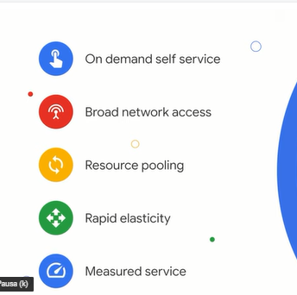

If you've decided to modernize your business IT infrastructure, you might be wondering what options are available to you.

In this video I'll explore the three main options that you can use to modernize your infrastructure, virtual machines, containerization, and serverless computing.

I'll also touch on Kubernetes, a solution for managing your services and machines.

First, let's make sure we have a shared understanding of key terms.

In the context of the cloud, compute or computing refers to a machine's ability to process information to store, retrieve, compare and analyze it, and automate tasks often done by computer programs, otherwise known as software or applications.

Traditionally, the hardware available for computing could only run a limited amount of software and applications.

As you learned in the last video virtualization changed this.

Virtualization is a form of resource optimization that allows multiple systems to run on the same hardware.

These systems are called virtual machines, or VMs.

This means they share the same pool of computer processing, storage and networking resources.

VMs enable businesses to have multiple applications running at the same time on a server in a way that is efficient and manageable.

The software layer that enables this is called a hypervisor. Hypervisor sits on top of physical hardware and multiple VMs are built on top of it. It's like having multiple computers that only use one piece of hardware.

Virtual machines are the first compute option for infrastructure modernization.

The second is **containers**.

Containers follow the same principle as virtual machines.

They provide isolated environments to run your software services and optimize resources from one piece of hardware. However, they're even more efficient. Virtual machines recreate a full representation of the hardware.

By contrast, containers only recreate or virtualize the operating systems. This means that they only contain exactly what's needed for the particular application that they support.

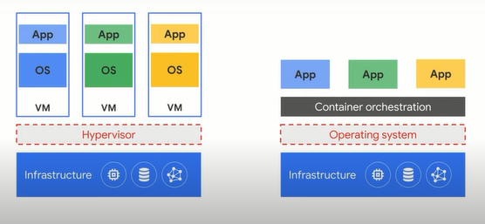

Containers offer a far more lightweight unit for developers and IT operations teams to work with and provide a range of benefits.

They start faster, and use a fraction of the memory compared to booting an entire operating system.

Containers give developers the ability to create predictable environments that are isolated from other obligations.

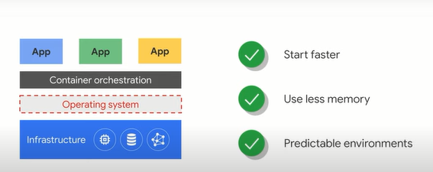

Let me use an analogy to explain the advantage of containers.

Suppose you want to build an apartment block.

One way to do this is to start with the steel beams, then build the outside walls, then run the electricity and plumbing, then build the interior walls.

However, if you discover a fault somewhere in the building, it can be very difficult to isolate the problem because everything is connected. Adjusting features of each apartment or fixing problems can be challenging and expensive.

Another way of doing Building an apartment block is to use prefabricated units.

In other words, you build the units off site, and then essentially lay them on top of each other. This means that any problem that arises is easier to isolate and fix. It also means that individual apartments can have unique designs with different features because they're all compartmentalized, rather than one giant unit.

This is what containers do for your applications.

So if a customer asked for a new feature, or a change in the application, your developers can easily make an update to that particular part of the application without affecting the rest. Containers are able to run virtually anywhere, which makes development and deployment easy. They can run on Linux, Windows and Mac operating systems on virtual machines, bare metal, which means directly on the hardware, on a developer's machine, or in data centers on premises, and of course, in the public cloud.

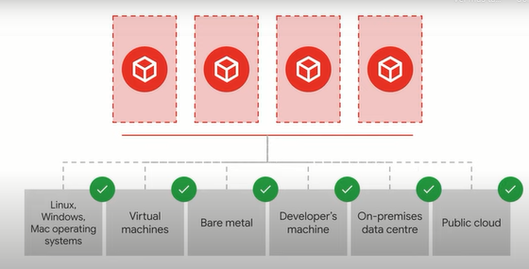

Containers improve agility, strength and security, optimize resources and simplify managing applications in the cloud.

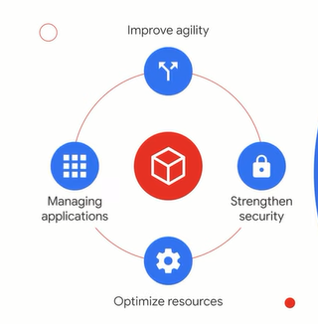

Many businesses have a mix of VMs and containers. However, as their IT infrastructure setup becomes more complex, businesses need a way to manage their services and machines.

For example, businesses can have millions and millions of containers. This means that keeping them secure and making sure that they operate efficiently can require significant oversight (*vigilancia*), and management.

Kubernetes is an open source cluster management system that provides automated container orchestration.

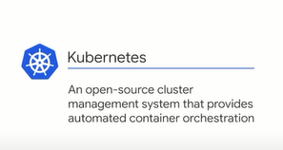

In other words, Kubernetes simplifies the management of your machines and services for you. This improves application reliability, and reduces the time and resources you need to spend on development and operations, not to mention the relief from the stress attached to these tasks. Kubernetes makes everything associated with deploying and managing your application easier. We'll explore Kubernetes and Google Kubernetes engine more in Module Two when we examine application development.

Finally, the third compute option is **serverless computing**. Serverless computing doesn't mean there's no server though. Serverless computing **means that resources such as compute power are automatically provisioned behind the scenes as needed.** This means that businesses do not pay for compute power unless they're actually running a query or application. At its simplest, serverless means that businesses provide the code for whatever function they want, and the public cloud provider does everything else.

Let me give you an example.

Imagine you're a healthcare technology company. You help general practice doctors to seamlessly (*perfectamente*) connect with their patients. One tool you provide is an application for patients to book appointments with their doctor. You want to add a feature that enables patients to upload an image with their appointment booking. In this case, the ability to upload an image is called a function. You, as the healthcare technology company, write the code for that function directly into your public cloud platform. The public cloud provider manages everything else.

For this reason, **serverless computing solutions are often called function as a service**. Some functions are a response to specific events like file uploads to your cloud storage or changes to your database records. You write the code that defines the response to those events, and your cloud provider does everything else. Ultimately, every business has different compute requirements based on where they are in their cloud adoption journey. As such, determining the right blend of compute solutions is a necessary part of any business cloud strategy.

Now, before we talk about Google Cloud compute solutions, I want to cover a key dimension of your cloud strategy. That is your service architecture.

I'll explain more in the next video.

**Hybrid and multi cloud.**

Today, most of the world's enterprise computing still happens on-premises. It hasn't moved to the cloud yet because path forward is complex, daunting (*desalentador*), and full of difficult decisions.

Sometimes workloads remain on-premises due to compliance or operational concerns.

So how do you modernize the infrastructure you have without jumping completely to the cloud?

How do you bridge incompatible architectures while you transition?

How do you maintain flexibility and avoid lock-in? (*evita el bloqueo*)

Although there are many benefits to developing cloud first or cloud native applications and systems, many enterprises have complex need that will involve some on-premises infrastructure working in conjunction with public cloud services provided by companies like Google Cloud. Before we go any further though, let's make sure we're using a standard definition for the following terms: **Private cloud, hybrid cloud, and multi-cloud.**

**Private cloud** is where an organization has virtualized servers in its own data centers to create its own private on-premises environment. This might be done when an organization has already made significant investments in its own infrastructure or if, for regulatory reasons, data needs to be kept on-premises.

**Hybrid cloud** is when an organization is using some combination of on-premises or private cloud infrastructure and public cloud services. This is the situation many organizations are currently in. Some of their data and applications have been migrated to the cloud. Others remain on-premises and interconnects between the private and public clouds allow interoperability.

**Multi-cloud** is where an organization is using multiple public cloud providers as part of its architecture. In this case, the organization needs flexibility and secure connectivity between the different networks involved.

An organization might choose to use either hybrid cloud or multi-cloud if they want to incorporate specific elements of a public cloud in order to take advantage of the key strengths of that provider.

For example, many organizations see enormous benefits from Google's BigQuery data analytics tool, a serverless application that scales to multi-petabyte data sets, but may keep the core applications generating data that needs to be processed on-premises. When organizations are considering a move to a hybrid cloud or multi-cloud situation, they are often concerned about how easy it will be to move an application from one cloud to another.

Google believes that being tied to a particular cloud shouldn't get in the way of you achieving your goals.

Instead, Google believes in an open cloud where users have the rights to move their data as they choose. If organizations have the power to deliver their apps to different clouds while using a common development and operations approach, this will help them meet their business priorities and rapidly accelerate innovation. Open source in the cloud preserves an organization's control over where they deploy their IT investments.

Let's look at some examples.

Because Google Cloud uses open APIs, Google services are compatible with open-source services and products. This means you can take the code from, let's say, Google's Cloud Bigtable, a manage database, and use that code somewhere else. Because Google Cloud publishes key elements of its technology using open-source licenses, customers can use products both on-premises and on multiple clouds.

One example of an open-source service you may have heard of is **TensorFlow**, and open-source software library for machine learning developed inside Google.

Another you may have heard of is **Kubernetes**, a system for automating application deployment, scaling, and management using a concept known as containerization.

Finally, Google Cloud has created **Anthos**, an open application modernization platform that enables you to modernize your existing applications, build new ones, and run them anywhere. It allows you to build an application once and run it wherever you want, on-premises, on Google Cloud, on a different public cloud. This will help accelerate application development for your organization.

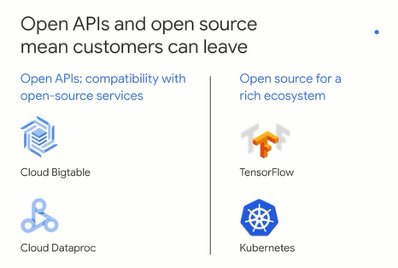

These examples of open-source solutions in the cloud enable businesses to leverage Google Cloud infrastructure and deploy applications using Google Cloud's solutions on-premises and/or using another cloud provider. The reliability and resilience of the cloud infrastructure is critical to business operations and success. Now, another key component of a cloud strategy is a secure network. Google's network carries as much as 40% of the world's internet traffic every day. In fact, Google's network is the largest of its kind on Earth, and Google has invested billions of dollars over the years to build it. Google Cloud customers are able to run their applications and services on the same infrastructure that Google uses to serve billions of users around the world. The network is truly global, operating in over 200 countries and territories with 20 regions and over 130 points of access. This means that customers benefit from a private, well-provisioned, highly reliable global network. Now, you might be considering multiple factors as part of your cloud strategy, such as cost, security, openness, and of course, the value of available products and services. Perhaps like us at Google, you're taking the environment into consideration, too. By moving compute from a self-managed data center or colocation facility to Google Cloud, the net emissions directly associated with your company's compute and data storage will be zero.

Why?

Because Google Cloud matches 100% of the energy consumed by our global operations with renewable energy and maintains a commitment to carbon neutrality. So **when you use Google Cloud to store your data and develop your applications, for example, your digital footprint is offset with clean energy, which reduces your impact on the environment.**

The takeaway (*conclusion*) is that every organization needs to think about their cloud strategy and understand the available options.

Google Cloud provides a range of infrastructure solutions to help business modernize and better serve their customers.

In the next video, I'll cover what those solutions are by category.

**Google Cloud Compute Solutions.**

So far, you've learned about the benefits of infrastructure modernization, the various compute options available, including virtual machines, containerization, and serverless computing. You've learned the difference between private, hybrid, and multi-cloud strategy and the benefits of the global infrastructure that Google Cloud provides.

Now let's look at some specific Google Cloud solutions.

In this video, I'll cover **VM-based compute options**, including **Compute Engine, Google Cloud VMware Engine, and Bare Metal.** Next, I'll look at **Google Kubernetes Engine, or GKE**, which is a container-based compute option. Finally, I'll explore three **serverless** computing solutions**, App Engine, Cloud Functions, and Cloud Run**.

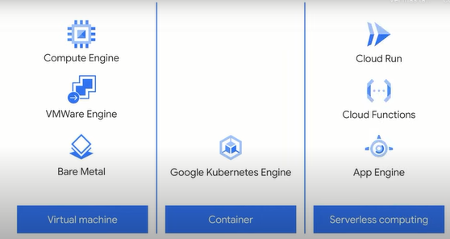

Let's start with **Compute Engine**, which is a computing and hosting service that lets you create and run virtual machines on Google's infrastructure. Compute Engine delivers scalable, high performance virtual machines running in Google's innovative data centers and worldwide fiber network. Compute Engine VMs boot quickly, come with persistent disk storage, and deliver consistent performance. This solution is ideal if you need complete control over the virtual machine infrastructure. It's also useful if you need to run a software package that can't easily be containerized or have existing VM images to move to the cloud. To better understand how Compute Engine works, let's turn to an example of a company that used this option to overcome challenges and scale their business. Spotify had reached a tipping point with their current business model where it wouldn't be able to scale any further. By leveraging Compute Engine, Spotify was able to effortlessly scale their business to reach millions of users. Google Cloud has allowed Spotify to build the audio network of the future and continue innovating, all while providing users with billions of unique experiences.

Another VM-based solution is Google Cloud **VMware Engine**. This is a type of software that you can run on a virtual machine. Google Cloud VMware Engine is a fully managed service that lets you run the VMware platform in Google Cloud. Google manages the infrastructure, networking, and management services, so that you can use the VMware platform efficiently and securely. An example of a company that uses Google Cloud VMware Engine is DBG, one of the world's leading exchange organizations. They use Google Cloud as the foundation for a scalable, resilient, and compliant infrastructure for financial markets. Using Google Cloud VMware Engine, DBG was able to spin up a new private cloud in under 40 minutes with minimal disruption his enabled them to scale their business on demand and meet customer needs while still using their VM tools and existing processes.

The final VM-based compute solution we'll cover today is **Bare Metal**.

You can migrate many existing workloads to the cloud easily. However, some specialized workloads are difficult to migrate to a cloud environment. These workloads require hardware, and complicated licensing, and support agreements. Bare Metal enables you to migrate specialized workloads to the cloud while maintaining your existing investments and architecture. This allows you access to and integration with Google Cloud services with minimal latency.

Next, let's look at the Google Cloud container-based solution, **Google Kubernetes Engine**, often shortened to GKE.

Google Kubernetes Engine, or GKE, provides a managed environment for deploying, managing, and scaling your containerized applications using Google infrastructure. The GKE environment consists of multiple machines, specifically Compute Engine instances, grouped together to form a cluster. GKE allows you to securely speed up app development, streamline operations, and manage infrastructure. An example of a company that used GKE to improve their business is *Current*.

*Current* is a financial technology company that offers a debit card and app made for teenagers. Current uses GKE to improve time to market for application development by 400% while eliminating downtime for users.

Finally, I'll cover three **serverless computing solutions**.

Let's start with **App Engine**. Google App Engine is a platform as a service and cloud computing platform for developing and hosting web applications. App Engine lets app developers build scalable web and mobile backends in any programming language on a fully managed serverless platform. This means app developers can focus on writing code without having to manage the underlying infrastructure. IDEXX Laboratories, Inc. develops and manufactures veterinary care products and technologies, including diagnostic tools and information technology. IDEXX used Google App Engine to launch VetConnect Plus, an app that gives veterinarians anytime, anywhere access to clinical decision support data that keeps pets healthy. By leveraging Google App Engine, IDEXX Laboratories was able to save up to $500,000 in annual IT spend. Now let's look at another serverless computing solution, Cloud Run.

**Cloud Run** allows developers to build applications in their favorite programming language with their favorite dependencies and tools and deploy them in seconds. Cloud Run abstracts away all infrastructure management by automatically scaling up and down from zero almost instantly depending on user traffic. But how can Cloud Run improve businesses and offer real-world solutions? Well, Veolia Group provides access to water, waste, and energy resources for millions of people across 52 countries. It develops sustainable solutions to preserve and replenish these resources across communities and industries. By leveraging Cloud Run for their algorithms, Veolia has benefited from automatic scaling, multiple route support, and fast deployments, all while saving money.

The third serverless compute solution is **Cloud Functions**.

Cloud Functions is a serverless execution environment for building and connecting cloud services. It offers scalable, pay-as-you-go functions as a service to run your code with zero server management. Cloud Functions offers a simple and intuitive developer experience. You or your developers can simply write your code and let Google Cloud handle the operational infrastructure. With Cloud Functions, developers are also more agile as they can write and run small code snippets that respond to events. *Lucille Gam*es is a good example of a company that optimized their business by harnessing Cloud Functions. Lucille Games used Cloud Functions and other Google Cloud solutions to build apps, run servers, and create original games that can scale to millions of users on demand.

As I mentioned before, infrastructure modernization serves as the foundation for digital transformation. It's important to think carefully about your cloud strategy and what compute options you can leverage. How you build your architecture influences how your business harnesses applications, manages data, and ultimately develops and thrives with this ever-evolving digital age. Whether you're able to embrace innovation or whether you're constrained by your cloud environment is determined by the choices you make now. (*Como mencioné antes, la modernización de la infraestructura sirve como base para la transformación digital. Es importante pensar detenidamente en su estrategia de nube y qué opciones informáticas puede aprovechar. La forma en que crea su arquitectura influye en la forma en que su negocio aprovecha las aplicaciones, administra los datos y, en última instancia, se desarrolla y prospera con esta era digital en constante evolución. Las elecciones que haga ahora determinarán si puede adoptar la innovación o si está limitado por su entorno de nube.*)

In the next module, we'll explore another important factor in your cloud adoption journey, application development. Leveraging the right applications in your business can transform how you work and unlock new value.

And application development in the cloud doesn't belong exclusively to the IT team.

Click on the next module to find out more.

**Quiz.**

1. App Engine, Cloud Functions and Cloud Run are all what type of Google Cloud compute option? Select the correct answer.

**Serverless computing**

VM-based computing

Software computing

Hybrid computing

2. Aarav is a Chief Technical Officer and is considering using public cloud services, specifically to modernize their company’s IT infrastructure. Which of the following can Aarav use to build a business case for using an Infrastructure-as-a-Service (IaaS) solution? Select the correct answer.

**Maintenance work is outsourced to the cloud provider.**

Computer hardware shifts from hybrid to on-premises.

IT expenditure shifts from operational to capital.

Web application security is managed by the cloud provider.

3. A national hotel chain is using a combination of on-premises data centers and public cloud services for their IT infrastructure. What type of IT infrastructure model is this? Select the correct answer.

**Hybrid cloud**

Multi-cloud

Virtualization

Colocation

4. Which specific cloud computing feature helps businesses serve their customers without service interruption and in a cost-effective way? Select the correct answer. (*¿Qué característica específica de computación en la nube ayuda a las empresas a atender a sus clientes sin interrupción del servicio y de manera rentable?)*

**Elasticity**

On-demand service

Agility

Large Network Access

5. What do containers recreate or virtualize? Select the correct answer.

**Operating systems**

Virtual machines

Hardware

Hypervisor